**Drop Required User DB’s –SQL Server.**

**--TSQL Script to drop required User DB’s.**

-- TSQL Script to Drop required User Databases

use master

go

DECLARE @command nvarchar(max)

SET @command = ''

SELECT @command = @command

+ 'ALTER DATABASE [' + [name] + '] SET single_user with rollback immediate;'+CHAR(13)+CHAR(10)

+ 'DROP DATABASE [' + [name] +'];'+CHAR(13)+CHAR(10)

FROM [master].[sys].[databases]

where [name] in ( 'testdb1', 'testdb2', 'testdb3');

SELECT @command

EXECUTE sp_executesql @command

**Before Executing the above Drop User DB’s Query:**

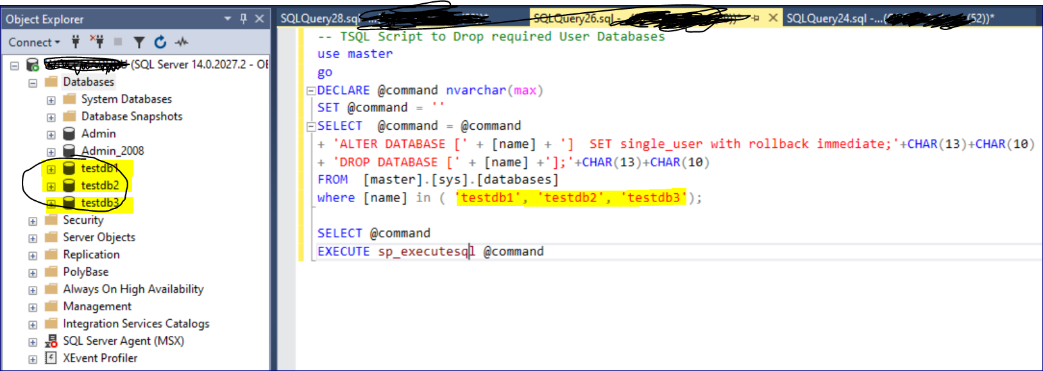

**After Executing the above Drop User DB’s Query. The mentioned user DB’s will get dropped immediately.**

